VOICES OF THE WILDERNESS

Alaskan artist-in-residence program
2020 INFORMATION
Sponsored by US Forest Service, National Park Service & US Fish & Wildlife Service

Residencies open to: Art professionals in all media – visual (two and three dimensional: photographers, sculptors, painters, etc.), audio (musicians, singers, composers), film (video/filmmakers), performance artists, and writers (poets, fiction, essays, storytellers).

Residency period: Typically June through August; dates & length of residencies vary.

Coordinator contact: Barbara Lydon at barbara.lydon@usda.gov
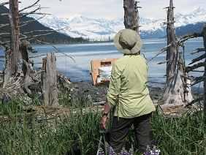
The Voices of the Wilderness artist residency is a unique opportunity. It is modeled after traditional residencies in the national parks…with a twist. Instead of staying at a remote wilderness cabin, our participating artists are paired with a wilderness specialist and actively engaged in stewardship projects, such as research, monitoring, and education. The idea is to give artists a sense of the stewardship behind America’s public lands, fostering an artistic exploration of these natural and cultural treasures. The hoped-for result is artwork that communicates something of the meaning of these lands.

2012 AIR Susan Watkins painting in Nellie Juan-College Fiord WSA

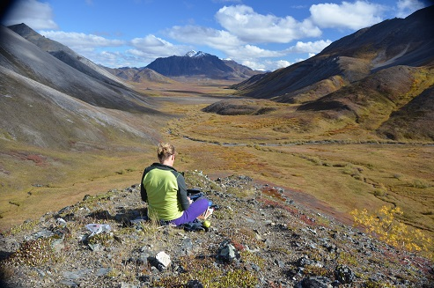
Artists in Public Lands

Artists have long contributed to the preservation and interpretation of our public lands. Early examples include George Catlin, Albert Beirstadt, and Thomas Moran, whose nineteenth-century paintings inspired pride in America’s wild landscapes and influenced designation of our first parks.

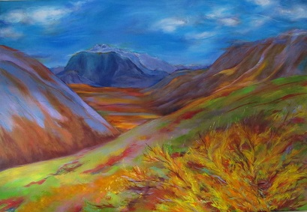
In subsequent generations, artists used song, photograph, poetry and other mediums to celebrate America’s public lands. Their work demonstrates that artistic expression plays a vital role in connecting people to the natural world.

Now it’s your turn.

Recognizing that today’s artists continue to link people to the land, the US Forest Service, National Park Service and US Fish & Wildlife Service are sponsoring Voices of the Wilderness, artist-in-residence opportunities hosted in some of Alaska’s wildest and most scenic areas.

Your job? It’s to be inspired. Experience the wilderness and use your creative energy to bring its voice back to the community.
2012 AIR MK MacNaughton painting in Western Arctic National Parklands

Artist-In-Residence

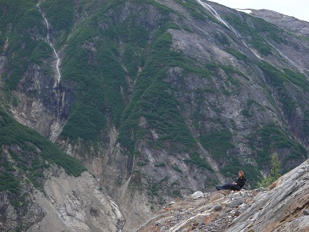
In the summer of 2020, artists will be invited to participate in our residencies, each opportunity completely different. The purpose is to share with the community artwork that conveys the inspirational and other values of wilderness.

Each artist will be provided the same safety training as other volunteers (may include aviation and boat safety, kayak safety, use of radios and satellite phones, review of Job Hazard Analyses, etc.). The hosting federal agency will provide transportation to and from the field, camping and field gear, and in many cases, food as well.

Travel to and from Alaska is the artist’s responsibility. Participants should plan to arrive in Alaska at least one full day prior to a residency to ensure enough time for safety training. Return travel should be planned for a couple days after a residency, as weather sometimes delays the return from the field. Artists are also responsible for their personal gear, including art supplies.
2011 AIR Marybeth Holleman writing in Tracy Arm-Ford’s Terror
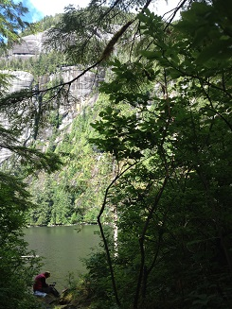

As an artist-in-residence, you will experience the wilderness like few others. Traveling alongside a ranger, you might kayak the calm fiords and camp on glacier-carved shores. There will be plenty of time to sit back in your camp chair and absorb the crackling ice bergs and roaring waterfalls. From the water, you might see a bear foraging among intertidal mussels, or seals hauled-out on the ice. On remote beaches, your steps will mingle with the tracks of wolves, bears, birds, maybe even a mink. The wilderness soundscape will embrace you with the screeches of eagles or the songs of whales. Along the way, you’ll get a peek at what it’s like to care for the land by sharing time with a ranger.

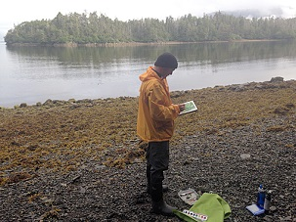

2013 AIR Sepand Shahab recording sounds in Misty Fiords

As a volunteer, each artist will assist with some basic ranger duties, which may include boarding a tour boat to provide education, participating in research projects, such as seal counts or climate change studies, walking a beach to remove litter, or other generally light duties. However, an emphasis for the artist will be experiencing the wilderness and exploring how to communicate its inspirational qualities through their artwork.
2014 AIR Ray Geier sketching in South Baranof

2020 Participating Wilderness Areas:
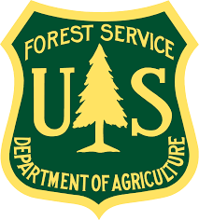
Kootznoowoo Wilderness
Tongass National Forest
US Forest Service

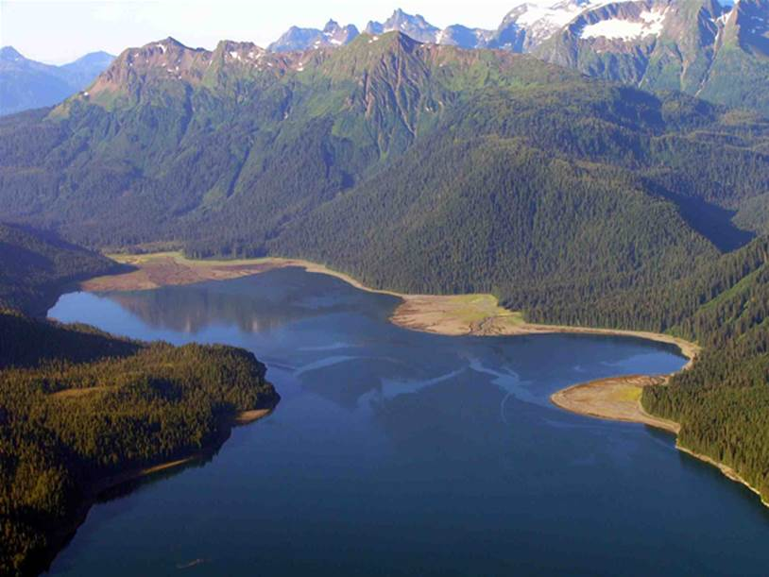

The Kootznoowoo Wilderness is on Admiralty Island near Juneau, Alaska. The name “Kootznoowoo” comes from the Tlingit people of Southeast Alaska, and means “the fortress of the bears”. This wilderness, which makes up almost all of Admiralty National Monument, is the largest remaining intact tract of temperate rainforest in the northern hemisphere. It hosts some of the densest populations of brown bears and nesting bald eagles in the world. The Kootznoowoo Wilderness has a rich cultural history and is home to the small Alaska Native community of Angoon which still relies on the bounty of the lands and waters for subsistence.

The selected artist will work with rangers administering the Pack Creek brown bear viewing area and also with wilderness stewards maintaining Admiralty Island cabins and trails. During the fieldtrip, the artist and rangers may stay in small tents, a rustic wall tent or historic cabins. Prospective artists should be prepared to camp, work and hike in bear country where conditions may be cold, wet, boggy and buggy. Transport to the wilderness will be by floatplane or skiff. Artists will depart for the field from Juneau. One artist will be selected to participate during the 2020 summer.

● www.fs.usda.gov/Internet/FSE_DOCUMENTS/stelprd3814489.pdf

For further questions about Kootznoowoo on Admiralty National Monument, contact
Kevin Hood: kevin.e.hood@usda.gov or (907) 789-6220
Misty Fjords National Monument
Tongass National Forest
US Forest Service
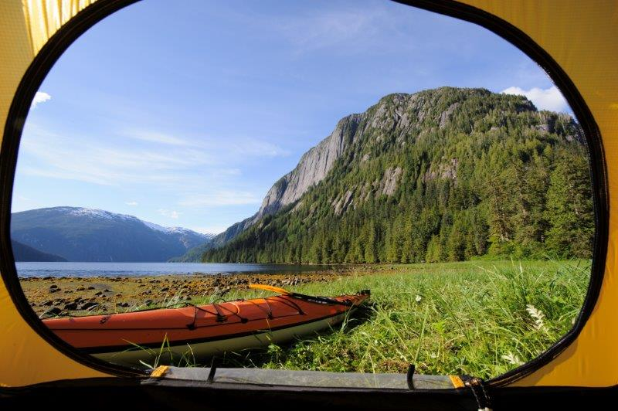
Misty Fjords National Monument Wilderness encompasses 2.2 million acres of coastal rainforest on the southern tip of the Alaska Panhandle. The area is characterized by numerous streams and river systems; alpine and subalpine lakes; forested mountains; and an abundance of fish and wildlife. Past glaciations have formed picturesque fiords, such as Walker Cove and Rudyerd Bay, which are surrounded by granite walls rising 3,000 feet above the ocean. Flight seers, boaters, and hikers come to Misty Fiords to photograph, kayak, explore, fish, and hunt, and to view the outstanding scenic beauty of the rugged terrain. Brown and black bears, mountain goats, and black-tailed deer are common sights in Misty Fjords. Moose, marten, wolves, wolverines, and river otters may also be found in abundance. All five species of salmon share the waters with sea lions, harbor seals, killer whales, humpback whales, and porpoises.

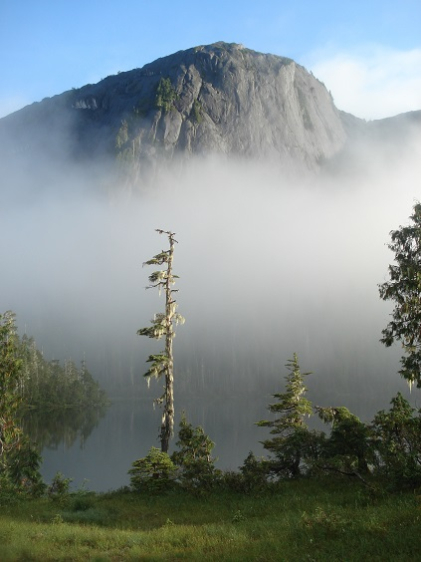
As an artist-in-residence, you will experience Misty Fjords like few others. Traveling alongside a ranger, you’ll kayak the fjords, hike trails to subalpine and alpine lakes, and camp along the shoreline. You’ll also assist with some basic ranger duties, which may include cleaning up campsites, monitoring visitor use, and light trail maintenance. The artist-in-residence selected will have outdoor experience and be physically and mentally prepared for a primitive travel and camping experience. Please be aware that Misty Fjords is located within a temperate rainforest with an average of 93 inches of rain per year. Expect weather to impact travel and field experience. As you work with wilderness managers, you’ll have plenty of time to take in the sights and sounds of the scenic landscape.

Artists will depart for the wilderness from Ketchikan.

● www.fs.usda.gov/Internet/FSE_DOCUMENTS/stelprd3814491.pdf

● https://www.facebook.com/votwmfnmartistresidency

Contact Denise Wolvin at Ketchikan Misty Fjords Ranger District for further questions about Misty Fjords National Monument: (907) 228-4134 or denise.wolvin@usda.gov

Nellie Juan-College Fiord Wilderness Study Area
Chugach National Forest
US Forest Service
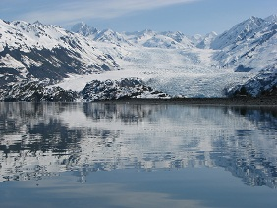
In 1980, Congress designated roughly two million acres along western Prince William Sound as the Nellie Juan-College Fiord Wilderness Study Area (WSA). This recognized the area’s exceptional beauty and remoteness and its possible future designation as federal wilderness. Until Congress determines the next step, the Forest Service is committed to preserving the area’s wilderness character to provide the public outstanding opportunities for solitude, primitive recreation, and inspiration in an undeveloped setting.

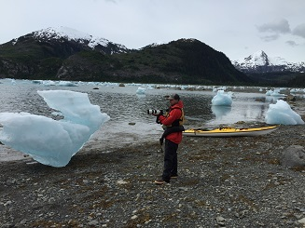
Located in south central Alaska on the Chugach National Forest, this wild landscape features countless glaciers-the densest concentration of tidewater glaciers in the world, some flowing a dozen miles from ice-capped peaks to terminate in cliffs of ice towering hundreds of feet above the water. The history of glaciation is evident everywhere you look, from newly de-glaciated barren hillsides, to ancient moraines just below the water’s surface.

Traveling by sea kayak in these expansive fiords, you’ll look straight up at peaks rising 2,000-9,000 feet right from the water’s edge. Camping alongside the ocean shores you’ll be able to follow the tracks of an animal, check out glacier ice up close, or take a short hike up to the alpine for an expansive glimpse of the fiords. Diverse wildlife is prevalent in the Sound, including black bears, humpback whales, sea otters, Dall’s porpoises, harbor seals and sea lions.

Artists will be partnered with rangers to participate in various wilderness stewardship duties, including accompanying a six-day teacher training course June 4-9, centered on the cultural and natural history of Prince William Sound. The full residency is targeted for June 1-17, but dates may change slightly. In addition to accompanying the ‘Teacher’s Expedition’, the selected artist may also be involved with invasive weed surveys, visitor contacts, wilderness character monitoring, and rehabilitation projects, and will be kayaking and boating while camping in remote areas of the Sound. During the residency, there will be plenty of time to experience the solitude and wildness of this place. Artist will depart for the field from the Glacier Ranger District in Girdwood, located approx. 40 miles southeast of Anchorage.

● www.pwsound.org
● www.fs.usda.gov/Internet/FSE_DOCUMENTS/fseprd520922.pdf
● https://www.facebook.com/votwnjcfwsaartistresidency

Contact Barbara Lydon at the Glacier Ranger District for further questions about Nellie Juan-College Fiord WSA: barbara.lydon@usda.gov
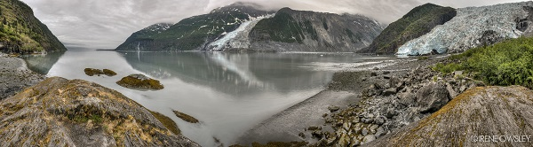

Sitka Ranger District Wilderness Areas:
South Baranof or West Chichagof-Yakobi Wilderness
Tongass National Forest
US Forest Service

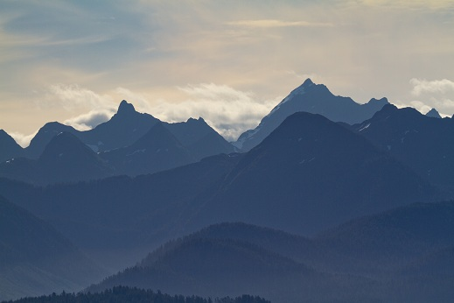
Alexander Baranof, the first governor of Russian America, built his headquarters in nearby Sitka and left his name on this large island (1,600 square miles) with most of the southern extremity of the island (319,568 acres) designated as the South Baranof Wilderness Area. Bounded on the west by the Gulf of Alaska, the scenery is stunningly picturesque with granite glacier-scored mountains, long saltwater fiords and hanging lake valleys. On the east side of the wilderness by Chatham Strait, the saltwater coastline is not as rugged and there is a higher snow accumulation over the whole area with over 200 inches of precipitation per year. Permanent snowfields and active glaciers blanket the high country above 2,000 feet, giving way to dense undergrowth in a coastal forest of spruce and hemlock. The wildlife that inhabits this area includes brown bears, Sitka black-tail deer, mink, marten and river otters, as wells as eagles and shorebirds. Seals, sea lions, whales, and a large population of sea otters are often seen offshore, and crab, shrimp, herring, salmon and halibut are harvested from the sea.

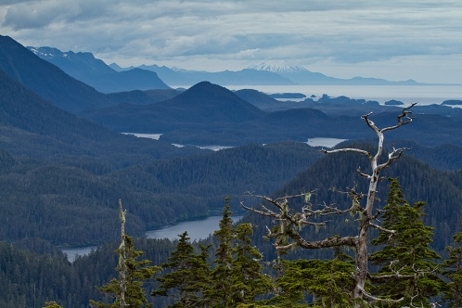
The West Chichagof–Yakobi Wilderness Area occupies the western portions of Chichagof and Yakobi Islands in the extreme northwest portion of the Alexander Archipelago of Southeast Alaska. The wilderness consists of 265,286 acres of wave-pounded open coastline, remote rivers, forests of old-growth western hemlock and Sitka spruce and uplands of alpine, muskeg, and rare karst cliffs. Sitka black-tailed deer are common here along with brown bears and an abundance of smaller furbearing animals including mink and marten. Migratory waterfowl frequent the more protected bays and inlets in remarkable numbers. Marine mammals include sea otters, Stellar sea lions, and harbor seals.

As an artist-in-residence you will be joining in a unique collaboration between the Sitka Ranger District and the Sitka Conservation Society in monitoring this rarely visited Wilderness Area. Access will be by floatplane or motorboat. Trips will consist of basecamps in remote locations or by roving monitoring from a sea kayak. Artists should be available for at least a two-week period to allow for adequate weather windows given the area’s exposure to the wide-open Pacific Ocean. Artists will depart from Sitka.

● www.fs.usda.gov/Internet/FSE_DOCUMENTS/stelprd3814496.pdf
● www.fs.usda.gov/Internet/FSE_DOCUMENTS/stelprd3814505.pdf
● https://www.facebook.com/votwsbwildernessartistresidency
● http://www.sierraclub.org/sierra/bones-tongass-kayaking-west-chichagof-yakobi-wilderness

Contact Rebecca Peterman at Sitka Ranger District for further questions about the Sitka Ranger District Wilderness area opportunities: (907) 747-4225 or rebecca.peterman@usda.gov

Tebenkof Bay Wilderness:
Tongass National Forest
US Forest Service

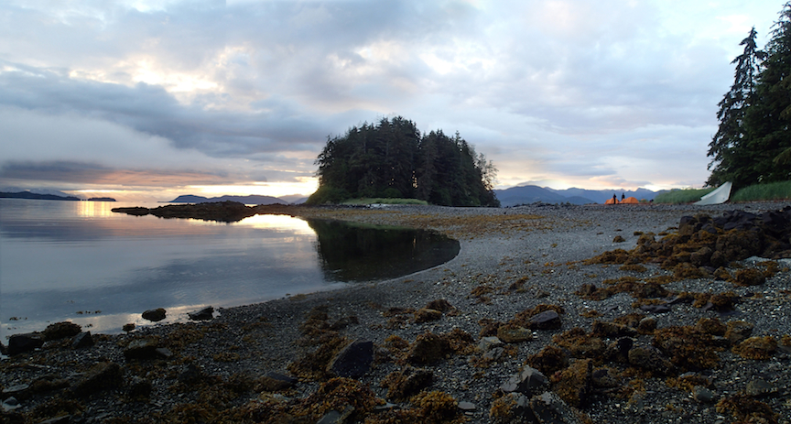
Tebenkof Bay Wilderness, located on Kuiu Island, comprises a complex system of smaller bays, where islands, islets, and coves are the prominent features. The western side is bound by Chatham Strait, a body of water exposed to the open ocean. The waters of the bay are home to sea otters, humpback whales, harbor seals and four types of salmon, while the land is covered by a thick forest of old growth, muskeg and alpine areas. Historically the Kake and Klawock Tlingit utilized Tebenkof Bay. They trapped, hunted, fished, gathered seaweed and gardened throughout the area. The bay was named in 1879 for Captain Tebenkov, governor of the Russian American colonies from 1845-1850. Early into the 20th century, canneries and salteries expanded into the coastal waters of what is now Alaska, and at least one of the industries operated within the bay during those formative years. At about the same time, the commercial raising of fur-bearing blue foxes spread. Almost every island group within Tebenkof Bay sheltered one of these businesses, but most were abandoned in the early 1940's. Commercial fishing continues inside the bay and in the outside waters.

Participating artists will be partnered with a ranger for a five to ten-day trip working on projects such as invasive plant eradication, encounter monitoring, wildlife monitoring and campsite inspections. The crew will live in small tents and travel will be by floatplane and kayak, spending days in what can be a cold and wet environment.

One artist will be selected to participate; the artist will depart for the field from Petersburg.

● https://www.facebook.com/pages/Voices-of-the-Wilderness-Petersburg-RD-Wilderness-Areas-Artist-Residency/416374945107014

● http://www.fs.usda.gov/Internet/FSE_DOCUMENTS/stelprd3814502.pdf

Contact Karisa Garner for further questions about this opportunity: (907) 772-5910 or karisa.garner@usda.gov
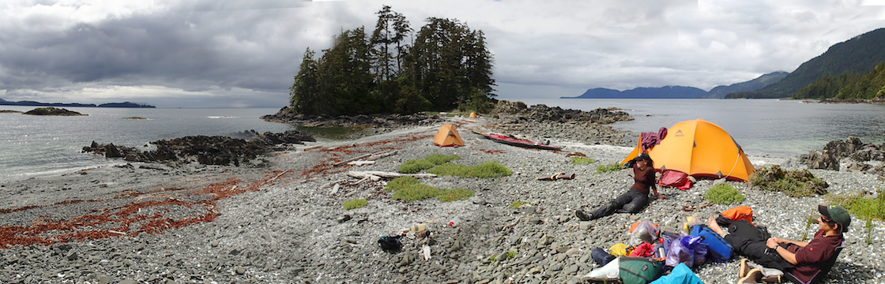

Tracy Arm-Ford’s Terror Wilderness
Tongass National Forest
US Forest Service

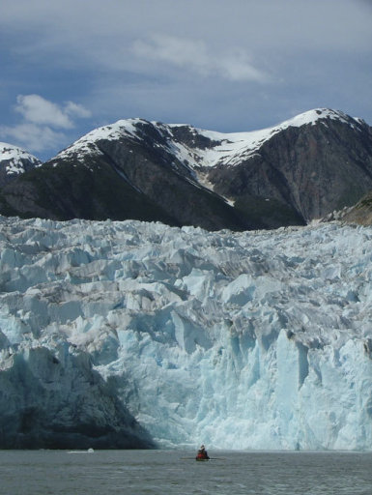
Tracy Arm-Fords Terror Wilderness is located fifty miles south of Juneau. This is a spectacular Wilderness Area cradling two steep-walled fjords that terminate at three of the most southerly tidewater glaciers in the northern hemisphere. Experience the abundance of life in an old-growth temperate rainforest, and then transition to the calving face of a tidewater glacier as it exposes land that hasn’t seen the sky in hundreds of years. Our stewardship projects here are as various as the characteristics of Wilderness. Artists may assist rangers in monitoring cruise ship emissions, providing shipboard education, treating invasive weeds, recording wildlife, and monitoring solitude.

Each selected artist will accompany a wilderness ranger approximately nine days. Artists will depart for Tracy Arm-Fords Terror from Juneau via floatplane or skiff. During the fieldtrip the artist will be accompanying a ranger, traveling primarily by sea kayak in the fjords and camping in a two-person tent in what can be a cold and wet environment. Applicants will participate in kayak training in Juneau before departing for the wilderness, and the district will provide all needed kayak and camping gear. The selected artist-in-residence should have backcountry experience and be physically and mentally prepared for primitive travel and camping.

● www.fs.usda.gov/Internet/FSE_DOCUMENTS/stelprd3814504.pdf

● https://www.facebook.com/votwtaftwildernessartistresidency

For further questions about Tracy Arm-Fords Terror Wilderness, contact at the Juneau Ranger District:
Sean Rielly: sean.rielly@usda.gov or (907) 789-6225
Or Chrissy Post: christine.post@usda.gov or (907) 789-6231
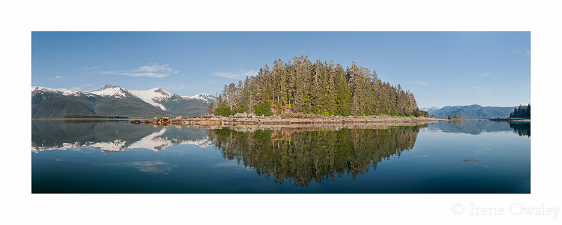
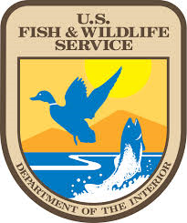
Aleutian Islands Wilderness
Alaska Maritime National Wildlife Refuge
US Fish & Wildlife Service
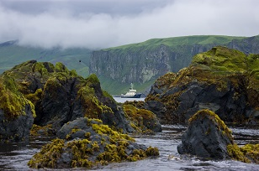
Alaska Maritime National Wildlife Refuge was established to conserve marine mammals, seabirds and other migratory birds, and the marine resources upon which they rely. The Refuge's 3.4 million acres include the spectacular volcanic islands of the Aleutian chain, the rich rainforests of the inside passage, the seabird cliffs of the remote Pribilofs, and icebound lands washed by the Chukchi Sea. This is a refuge of thousands of islands, and millions of birds.

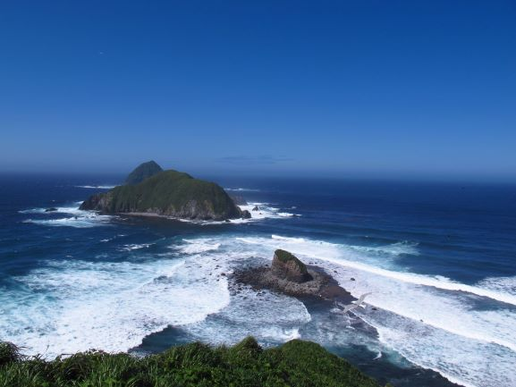
Much of this Refuge of islands and headlands is federally designated wilderness. Swirling clouds of seabirds, rare Asiatic migrant birds, beaches of bellowing sea lions and fur seals, and salmon streams in abundance are a few of the wildlife highlights on the Alaska Maritime Refuge. We access much of this remote refuge via our Research Vessel Tiglax. We're still developing our 2020 schedule and won't have the final draft until January, but we tentatively plan on having the artist visit the very remote Buldir Island for 7-20 days. We may choose another location as our schedule firms up in January.
Artists will be responsible for flying to an Alaska Adak Airport. Tentative field opportunities include travelling via the Research Vessel Tiglax to remote Buldir Island near the tip of the Aleutian Chain.
● https://www.alaskapublic.org/2015/09/28/buldir-island-a-life-changer-for-seabird-researchers/
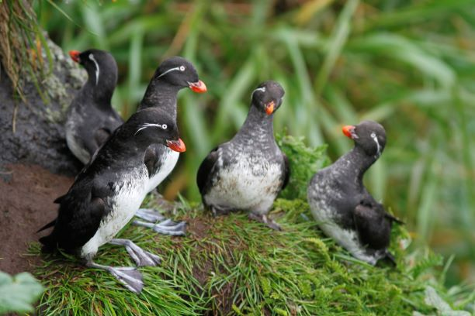
● www.fws.gov/refuge/alaska_maritime/
● www.fws.gov/refuge/Alaska_Maritime/what_we_do/mv_tiglax.html
● www.facebook.com/AlaskaMaritimeNationalWildlifeRefuge/

For more information about AK Maritime NWR, please contact Marianne_Aplin@fws.gov

Arctic Wilderness
Arctic National Wildlife Refuge
US Fish & Wildlife Service

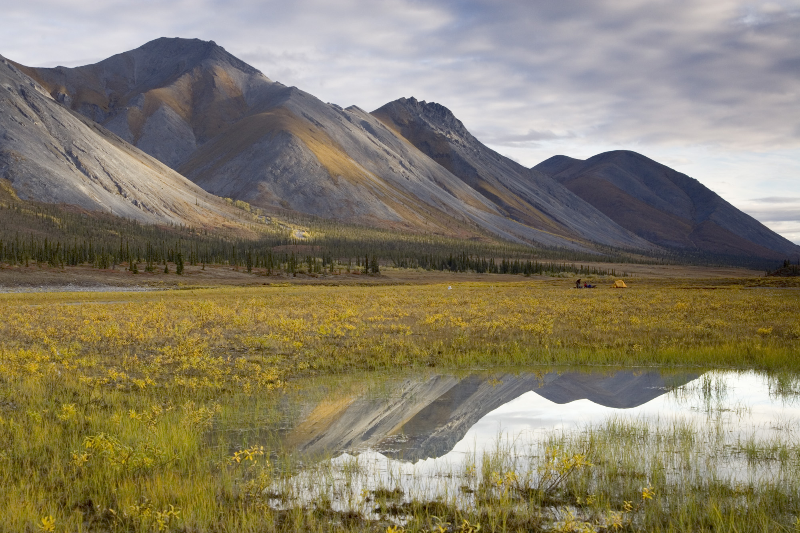
"Here was the living, moving, warm-blooded life of the Arctic...with the wisdom of the ages, moving always, not depleting their food supply, needing all these valleys and mountains in which to live."
-Margaret Murie, Refuge Founder

Arctic National Wildlife Range was established in 1960 to preserve unique wildlife, wilderness and recreational values. In 1980, the Alaska National Interest Lands Conservation Act (ANILCA) re-designated the Range as part of the Arctic National Wildlife Refuge, and provided four purposes that guide management of the entire Refuge: to conserve animals and plants in their natural diversity, ensure a place for hunting and gathering activities, protect water quality and quantity, and fulfill international wildlife treaty obligations.

Arctic Refuge is about 19.3 million acres in size. It’s approximately the size of South Carolina and has no roads, marked trails, or campgrounds. The Refuge includes an array of landscapes and wildlife habitats--from the boreal forest of the Porcupine River uplands . . . to the foothills and slopes of the Brooks Range . . . to the arctic tundra of the coastal plain . . . to the lagoons and barrier islands of the Beaufort Sea coast. Together these areas contain hundreds of species of mosses, grasses, wildflowers, shrubs and other plants. The Refuge contains the greatest wildlife diversity of any protected area in the circumpolar north.

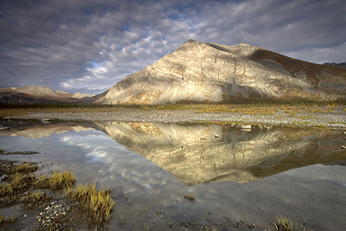
Arctic Refuge contains the largest area of designated Wilderness within the National Wildlife Refuge System, "where the earth and its community of life are untrammeled by man." [The Wilderness Act, 1964] The Arctic Refuge is recognized as one of the finest examples of wilderness left on the planet. It is among the last to be visited by modern man and among the least affected by his doings. It's a place where the wild has not been taken out of the wilderness.
Untold mountains, diverse wildlife and a wealth of habitats give this unspoiled national treasure first-rate cultural, scenic, scientific and experiential values. Values that are ageless. Values that make the Refuge a national symbol of wilderness. Arctic Refuge is a place that changes those who visit. It's a place whose existence strengthens our awareness of and sense of responsibility for the natural world.

The length of the residency will last from 7-20 days in length. Artists will be responsible for flying to Fairbanks International Airport and air travel to Arctic Refuge will be provided. Possible field opportunities include flying to a remote location with a field biologist and hiking to various locations within the Refuge. Another option would involve flying into a remote location and assisting a biologist on a float trip. There are also possible opportunities to fly into the rural communities of Arctic Village or Kaktovik, Alaska.

●www.fws.gov/refuge/arctic
●www.facebook.com/arcticnationalwildliferefuge

Contact Allyssa Morris, Environmental Education Specialist at Arctic National Wildlife Refuge for further questions: (907) 456-0224 or Allyssa_Morris@fws.gov

Innoko or Koyukuk Wilderness
Innoko/Koyukuk National Wildlife Refuge
US Fish & Wildlife Service

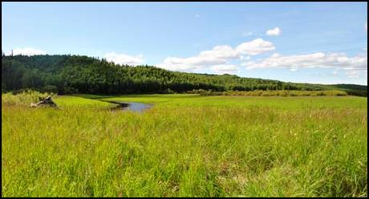
Innoko Wilderness:

In Alaska’s central interior, along the eastern bank of the Yukon River, lies the 3.85 million-acre Innoko National Wildlife Refuge. The meandering Innoko River bisects the refuge and forms the northern boundary of the Innoko Wilderness Area. The Wilderness comprises the southeastern portion of the refuge, roughly one-third of the total area (1.2 million acres). A transition zone between the boreal forestland of interior Alaska and the open tundra of western Alaska, Innoko stands well over half in wetlands of muskeg and marsh, lakes, meandering rivers, and streams dotted with islands of black spruce and an understory of mosses, lichens, and shrubs.

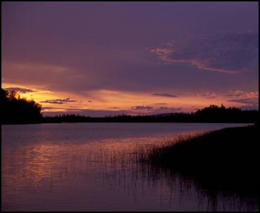
Paper birch and white spruce cover hills rolling up from the Yukon and Innoko Rivers. Along the rivers are numerous privately owned subsistence camps used periodically for hunting and fishing by Native Alaskans. The rivers, edged by willows and alder, run rich with salmon, whitefish, sheefish, grayling, and northern pike. All the lakes have northern pike except the shallow bodies of water that freeze to the bottom in winter.

More than 20,000 beavers live in Innoko’s wetlands, the densest population in the state, along with moose and caribou, black and brown bears, red foxes, coyotes, lynx, otters, wolves, and wolverines. An estimated 65,000 white-fronted and lesser Canada geese spend their summers here with more than 380,000 other waterfowl and shorebirds, including Northern Pintails, Greater and Lesser Scaup, Northern Shovelers, Scoters, Widgeons, Red-necked Grebes, Lesser Yellowlegs, and Hudsonian godwits. Hungry mosquitoes cloud the summer landscape, feeding thousands of nesting songbirds including Alder Flycatchers, Varied Thrush, Swainson's Thrush, Yellow Warblers, Yellow-rumped Warblers, Northern Waterthrush, Fox Sparrows and Savannah Sparrows.

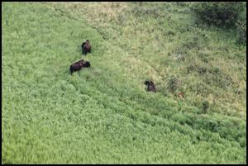
During spring and summer of 2015, the Alaska Department of Fish and Game released 130 wood bison to an area adjacent to the Innoko Wilderness as part of a project to restore this species to Alaska. Historic records indicate that wood bison roamed free in parts of Alaska up until about 200 years ago. Once thought to be extinct, the species has been restored to several areas in Canada. The wood bison in the Innoko area represent the only wild herd in the United States. The bison have expanded their range from the release site and now roam portions of the Innoko Refuge.

An artist in residence will journey to a remote field camp in the Innoko Wilderness by float plane (this requires special training, see below*) from the refuge headquarters in Galena, Alaska. The field camp, which includes small cabin accommodations, serves as base camp for biological monitoring and other refuge operations. The artist will have opportunities to explore the area while assisting refuge staff with field projects.

●http://www.fws.gov/refuge/innoko/

●https://www.facebook.com/KoyukukNowitna-National-Wildlife-Refuge-Complex-232615373583453/

●Wood bison: https://vimeo.com/144932367

Koyukuk Wilderness:

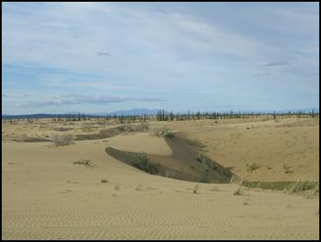
Think of 3.5-million-acre Koyukuk National Wildlife Refuge, and water comes to mind: there are 14 rivers, hundreds of meandering creeks, more than 15,000 lakes, all forming the floodplain of the Koyukuk River. The lands of the refuge are still of great importance to the Alaskans who live in villages within or adjacent to its boundaries.

Moose are common within the refuge. Brown and black bears wade into the rivers in night-less summer to escape swarms of mosquitoes and other biting insects. Lynx, coyotes, red foxes, wolves, and wolverines might also be seen. Beavers abound, and thousands of migratory waterfowl nest and raise their young within the productive river basin. The rivers and wetlands are also habitat to salmon, sheefish, pike and grayling. Local subsistence activities include gathering meat, fish and berries, trapping of furbearers, and cutting house logs and firewood. There are no roads and no maintained trails, but the lower Koyukuk River provides a "highway" through the heart of the refuge.

Four-hundred thousand acres of the Koyukuk Refuge are preserved as Wilderness. Miles of boreal forest surround a unique geological feature -- the Nogahabara Sand Dunes. The roughly circular active dune field spans about 6 miles in diameter, and was formed thousands of years ago when wind-blown glacial sand was deposited at the base of the Nulato Hills. The isolated dunes are lightly vegetated and continually shift with the wind.

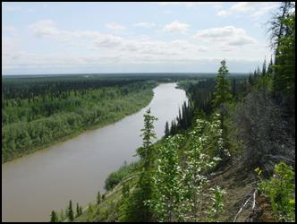
The Three-Day Slough area also lies within the Koyukuk Wilderness and is of both geologic and historic interest. The large vegetated dune sheets that surround the Nogahabara Sand Dunes end abruptly in tall silt bluffs here, exposing layers of geologic history along the water’s edge. The historic village of Kateel was also located in this area, and was an important site for trade between Koyukon Indians and neighboring Eskimos prior to the arrival of Europeans to the region. Archaeological evidence indicates that the area has been occupied by humans for many thousands of years. The Three-Day Slough area remains an important area for public use, primarily by moose-hunters in the fall. Fishing and hunting are allowed throughout the Refuge, subject to State and Federal regulations.

The Koyukuk Wilderness, like the rest of the Koyukuk Refuge, is very remote. A visit to the Wilderness is a bit like going back in time, and the trappings of modern life pale in relation to the awe inspiring wild. A visiting artist will visit the Wilderness by boat or float plane (this requires special training, see below*; access to the Nogahabara Sand Dunes is by float plane only). You may also have the opportunity to explore along the Yukon River and visit Athabascan villages near and within the refuge. The refuge headquarters is in Galena.

*Special Note: In order to travel by float plane to and from the Refuge as a volunteer for the U.S. Fish and Wildlife Service, the artist would be required to have completed the course “Water Ditching and Survival” before arriving in Galena, Alaska. For more information and to enroll in a free Water Ditching and Survival Course, go to the Interagency Aviation Training website at www.iat.gov, create a login and password, and look for A-312 course offerings. Check the website regularly; there are more course offerings during the spring prior to the summer field season. Once someone has taken the course in person in the classroom/swimming pool, they remain current by taking the online refresher A-325R every two years.

One artist may be selected for either Innoko or Koyukuk Wilderness.

● http://www.fws.gov/alaska/nwr/koyukuk/

●https://www.facebook.com/KoyukukNowitna-National-Wildlife-Refuge-Complex-232615373583453/

Contact Karin Bodony at the Koyukuk/Nowitna/Innoko National Wildlife Refuge for further questions about Koyukuk or Innoko: (907) 656-1231or karin_bodony@fws.gov

Togiak Wilderness
Togiak National Wildlife Refuge
US Fish & Wildlife Service

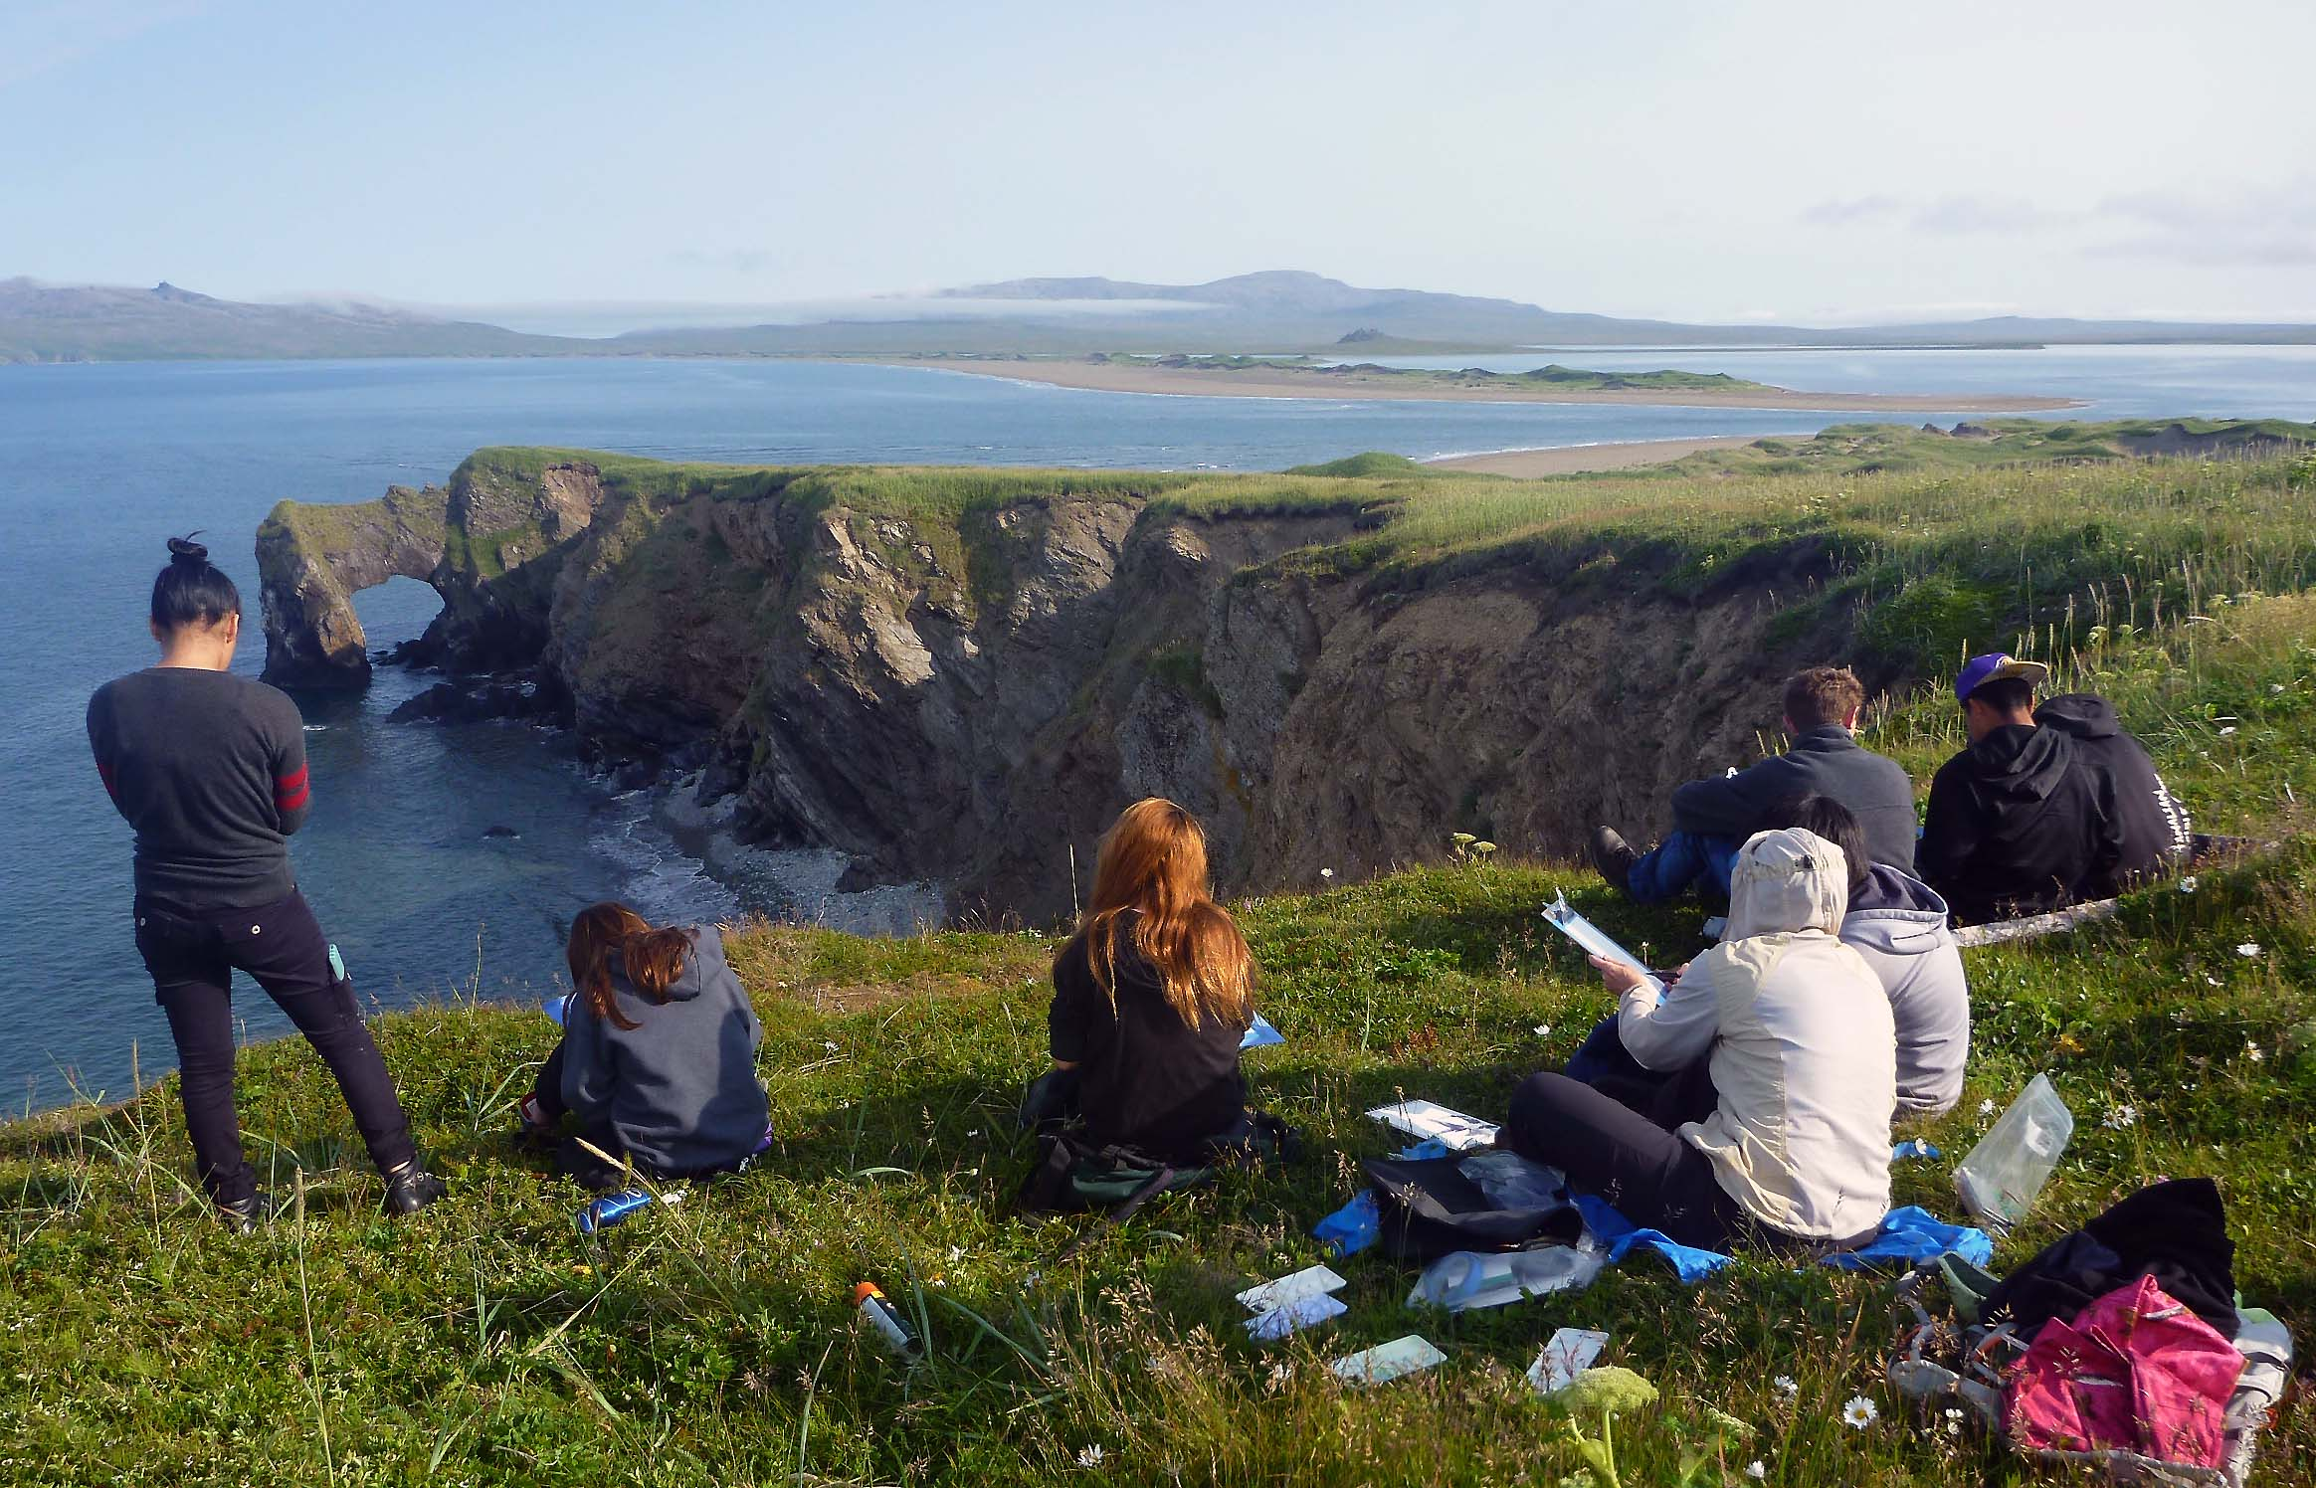
Togiak Refuge is a 4.7 million-acre expanse of mountain, river, and coastal habitats in southwestern Alaska - an area about the size of Connecticut and Rhode Island combined, but without the roads. The refuge is an incredibly diverse mix of ecosystems that provides homes to a varied range of wildlife populations. Craggy peaks tower 5000’ over broad glacial valleys of the Ahklun and Wood River mountains. Numerous rivers flow from mountainous headwaters and deep clear lakes toward the Kuskokwim and Bristol bays. The northern 2.3 million acres of Togiak Refuge have been designated as the Togiak Wilderness to preserve the pristine character of the land and the animals that make it their home. It is the second largest such block of designated wilderness in the National Wildlife Refuge System.
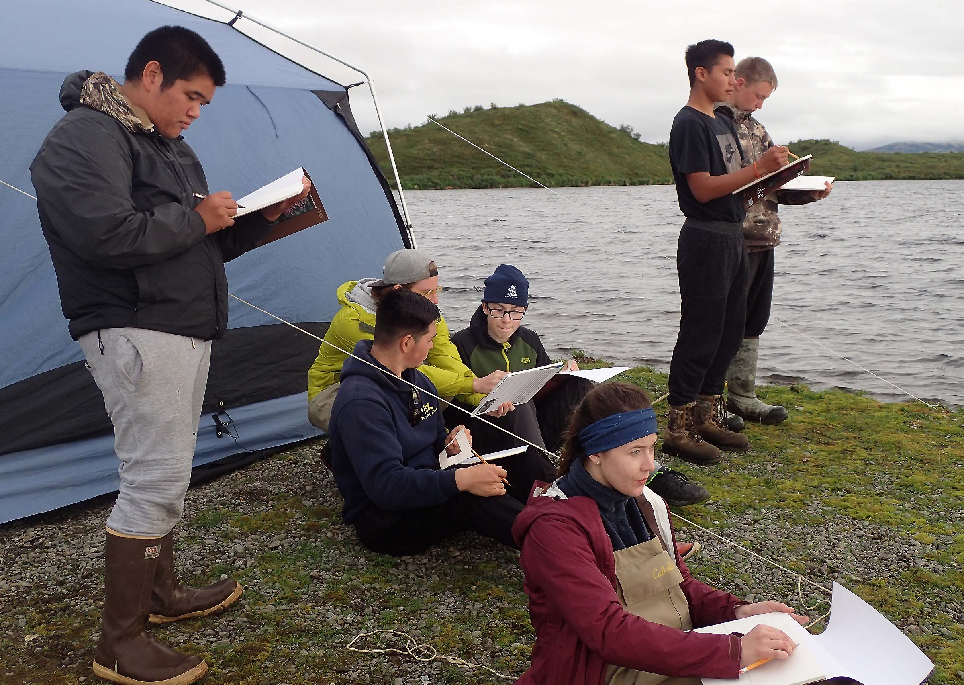
There are many numbers that define Togiak Refuge, including 1500 miles of rivers and streams, 600 miles of coastline, 500 lakes larger than 25 acres, over 500 types of plants, more than 200 bird species, 33 fish species, 31 land mammal species, and 17 marine mammal species. What can’t be defined as easily is the beauty found on the refuge. In the spring, the land comes to life as plants produce new growth, hibernating residents awaken, and migratory birds arrive by the tens of thousands. During the summer, when wildflower blooms cover the hillsides and over a million salmon run up Refuge rivers to spawn, animals busily feed, putting on weight for the cold winter months or their long journeys back to wintering areas. Autumn days grow shorter and the tundra takes on vibrant reds and yellows as the calendar once again winds down towards winter.

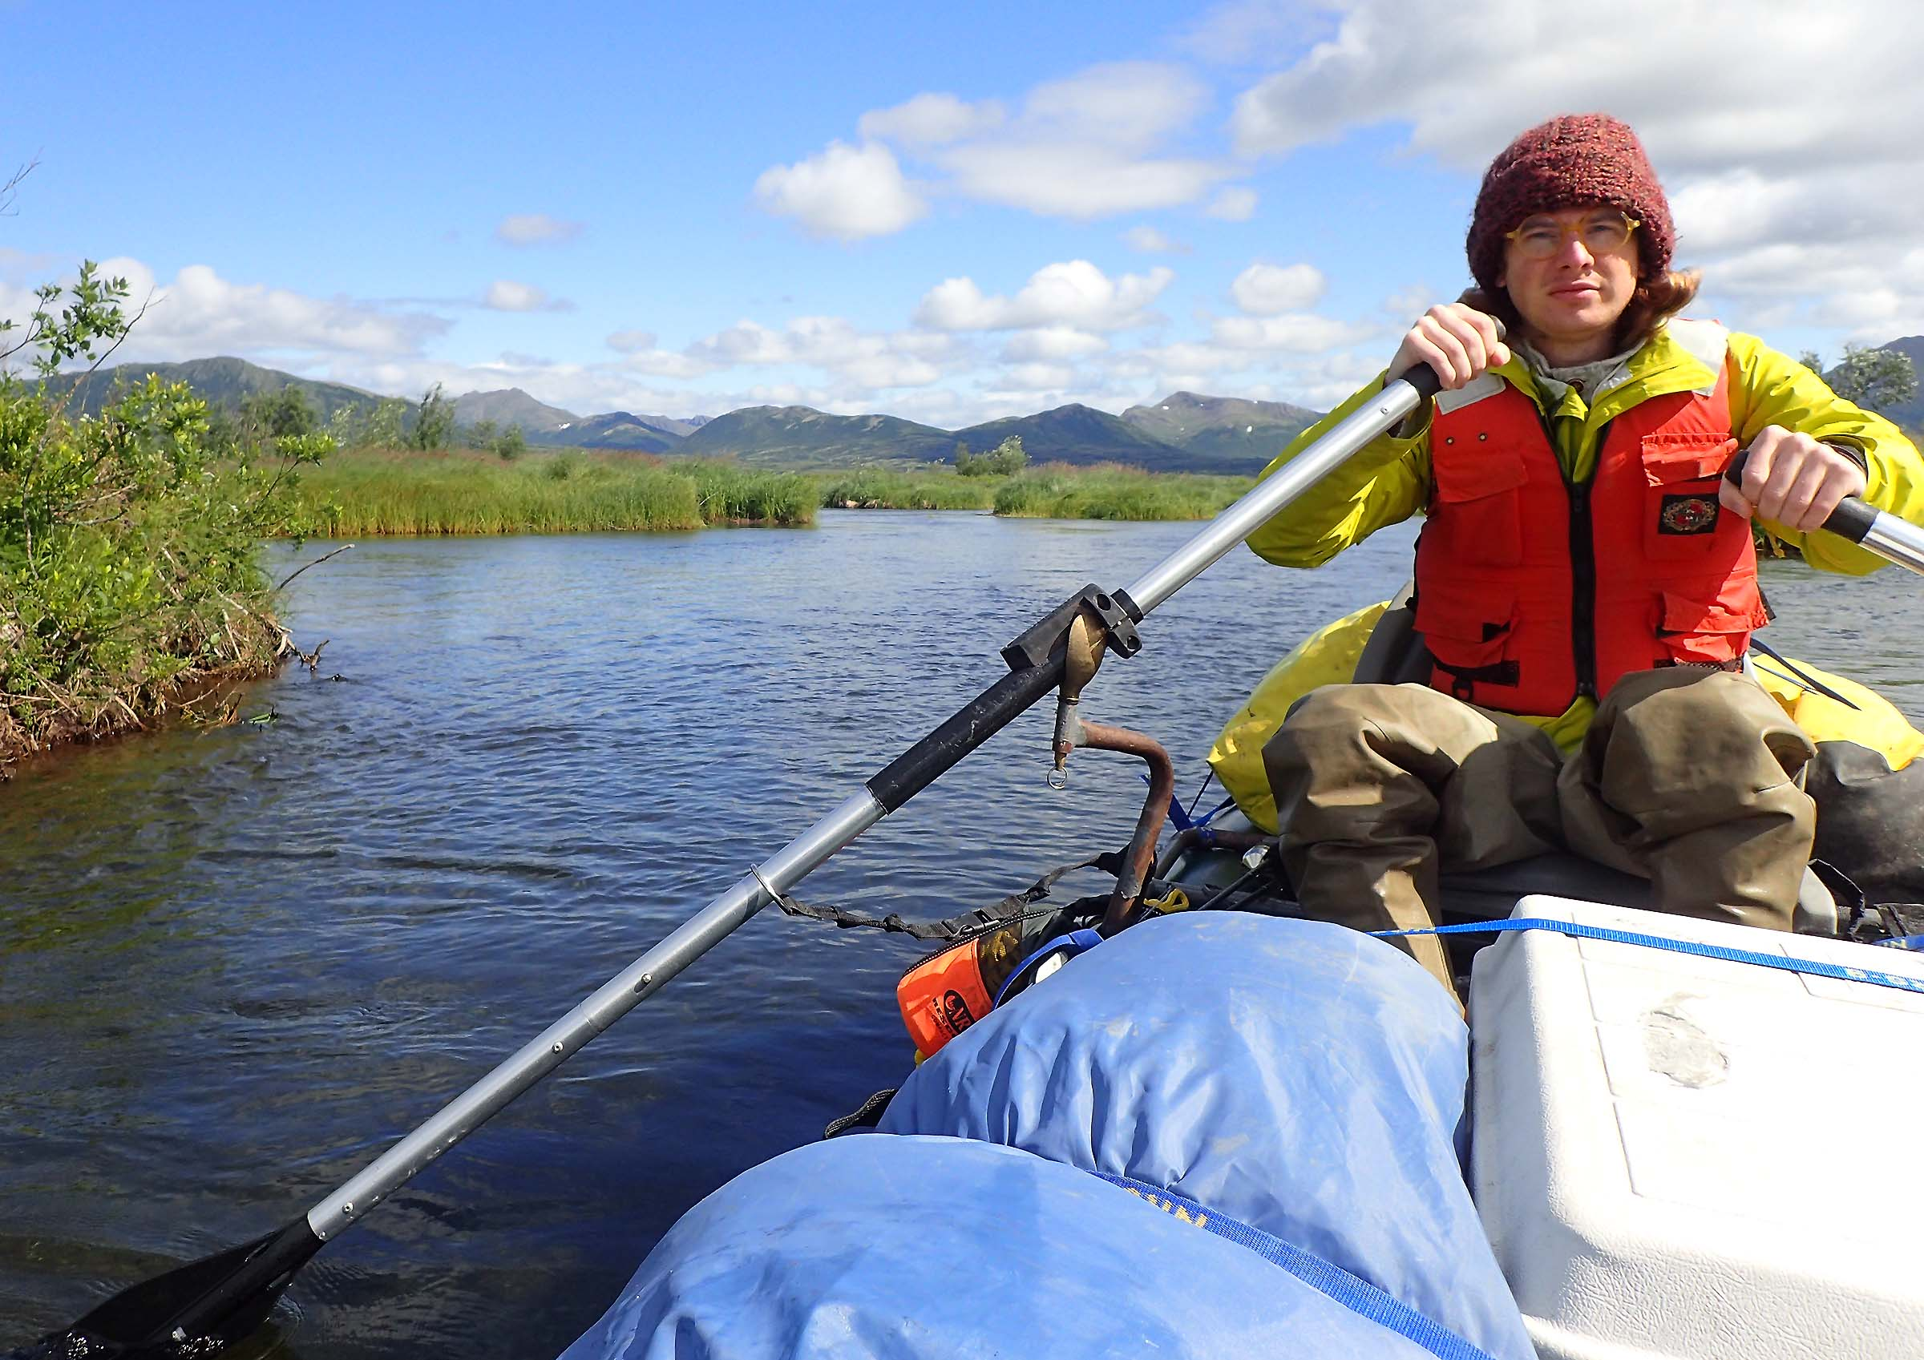
Depending on the timing of their visit, the selected artist may have the opportunity to take part in a five-day Environmental Education trip on the Refuge either (1) rafting on a Refuge river with six local high school students [typically the first full week of August], or (2) travelling to Cape Peirce with eight middle school students and staying in two cabins, beachcombing, hiking, and observing wildlife [typically the first full week after the 4th of July weekend ]. In either case, the artist would be able to share their talents with the students during the trip, sharing trip and instructional responsibilities with Refuge employees. There may also be other opportunities to join a biologist on a trip to the field to study wildlife or fish. [Note: In order to participate in any of those three trips (which require travel by float plane), the artist would be required to have completed the course “Water Ditching and Survival” before arriving in Dillingham, Alaska*].

If the selected artist is unable to take the Water Ditching and Survival course, or their visit must take place on dates that do not correspond with the trips described above, they would have the opportunity to do a multi-day River Ranger jet-boat patrol on the Togiak River or to propose and provide an art instructional program or presentation for residents in Dillingham, AK. Neither of those two options would require the completion of the Water Ditching and Survival course.

The selected artist is responsible for their own airfare to and from Dillingham. While there, groceries and bunkhouse accommodations, along with transportation around Dillingham and to and from the Refuge will be provided.

*For more information and to enroll in a free Water Ditching and Survival Course, go to the Interagency Aviation Training website at www.iat.gov, create a login and password, and look for A-312 course offerings. Check the website regularly; there are more course offerings during the spring prior to the summer field season. Once someone has taken the course in person in the classroom/swimming pool, they remain current by taking the online refresher A-325R every two years.
● www.fws.gov/refuge/Togiak ● www.facebook.com/Togiak-National-Wildlife-Refuge

Contact Terry Fuller at Togiak with questions (907) 842-8419 or terry_fuller@fws.gov
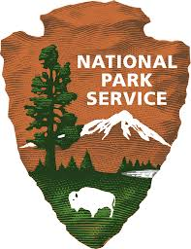
Noatak Wilderness
Western Arctic National Parklands
National Park Service

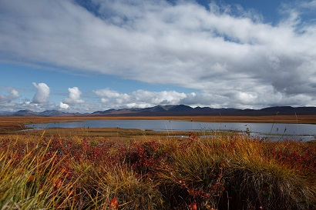

Western Arctic National Parklands, located in the northwest corner of Alaska, consist of four Park units - Noatak National Preserve, Kobuk Valley National Park, Cape Krusenstern National Monument, and Bering Land Bridge National Preserve.

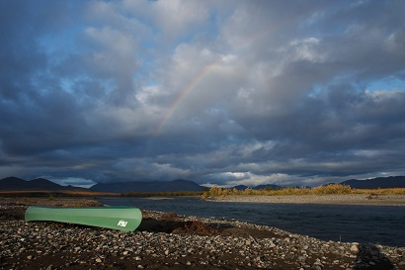
Noatak National Preserve protects almost the entirety of the largest untouched river basin in America, that of the Noatak River. All the preserve, except for about 700,000 acres around the village of Noatak, has been designated Wilderness. The Noatak River flows westward 425 miles through the heart of the preserve to Kotzebue Sound, carving the scenic Grand Canyon of the Noatak along its course. From its source to its confluence with the Kelly River, 330 miles have been designated Wild and Scenic, making it the longest river in the Wild and Scenic System. More and more visitors each year come to canoe and kayak on the Noatak, and almost the entire river may be paddled easily. Those who fish catch Arctic char, grayling, whitefish, or salmon. The Western Arctic caribou herd roams, 450,000-plus strong. Backpacking in the foothills, among the bears, wolves, lynx, wolverine, and Dall sheep, has been increasing in popularity, and backcountry travelers must move with care, as this land is fragile. Bird life abounds in the migratory seasons. Camping is unrestricted, but you should avoid the numerous private lands on the lower Noatak River. Campsites are best on river sandbars and high, dry tundra knobs. Motorboats, small airplanes, and snowmobiles are permitted. Hunting and fishing are allowed.

The majority of our backcountry patrols utilize canoes for the Noatak and Kobuk Rivers. The selected artist for this residency will accompany one of our backcountry rangers for an 8-10 day wilderness stewardship project.

Successful applicant will provide their own transportation to Kotzebue. NPS will provide all field gear and food, and all backcountry flights. Outdoor skills resume required in order to receive consideration.

● https://www.facebook.com/votwwanpartistresidency

Contact Interpretation and Education Program Manager Tyler Teuscher at Tyler_Teuscher@nps.gov or
(907) 442-8321

Wrangell-Saint Elias Wilderness
Wrangell-Saint Elias National Park
National Park Service

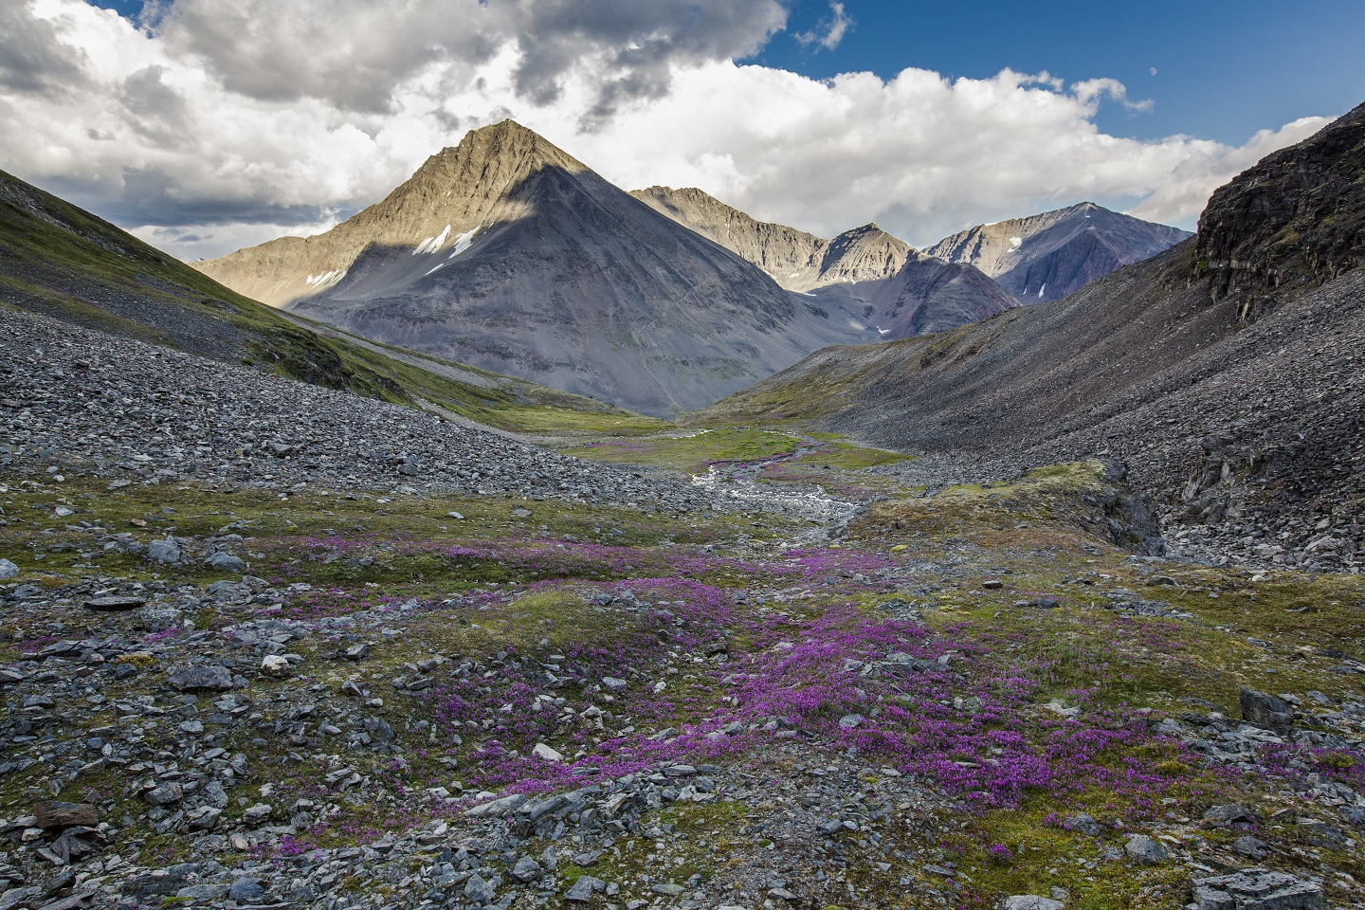
Wrangell-St. Elias National Park and Preserve is a big place. From sea to summit, the park encompasses over 20,500 square miles and rears up nine of the sixteen highest peaks on the continent. Sheer size and scale are what allows for the existence of the wilderness qualities that make Wrangell-St. Elias unique, and it is the primary theme that repeats throughout any description of its wilderness character. Wrangell-St. Elias wilderness is an “inhabited wilderness” where local communities and traditional human activities remain integrated within the larger landscape. Within the park, continuance of living cultures is ensured by the opportunity for local people to engage in a traditional subsistence way of life. The wilderness also contains several historic mining areas. These sites and their remains are a testament to the will and determination of people to carve out a living within a truly wild place. The abandoned ruins of human endeavor only serve to highlight western man’s transience in this timeless and immense landscape.
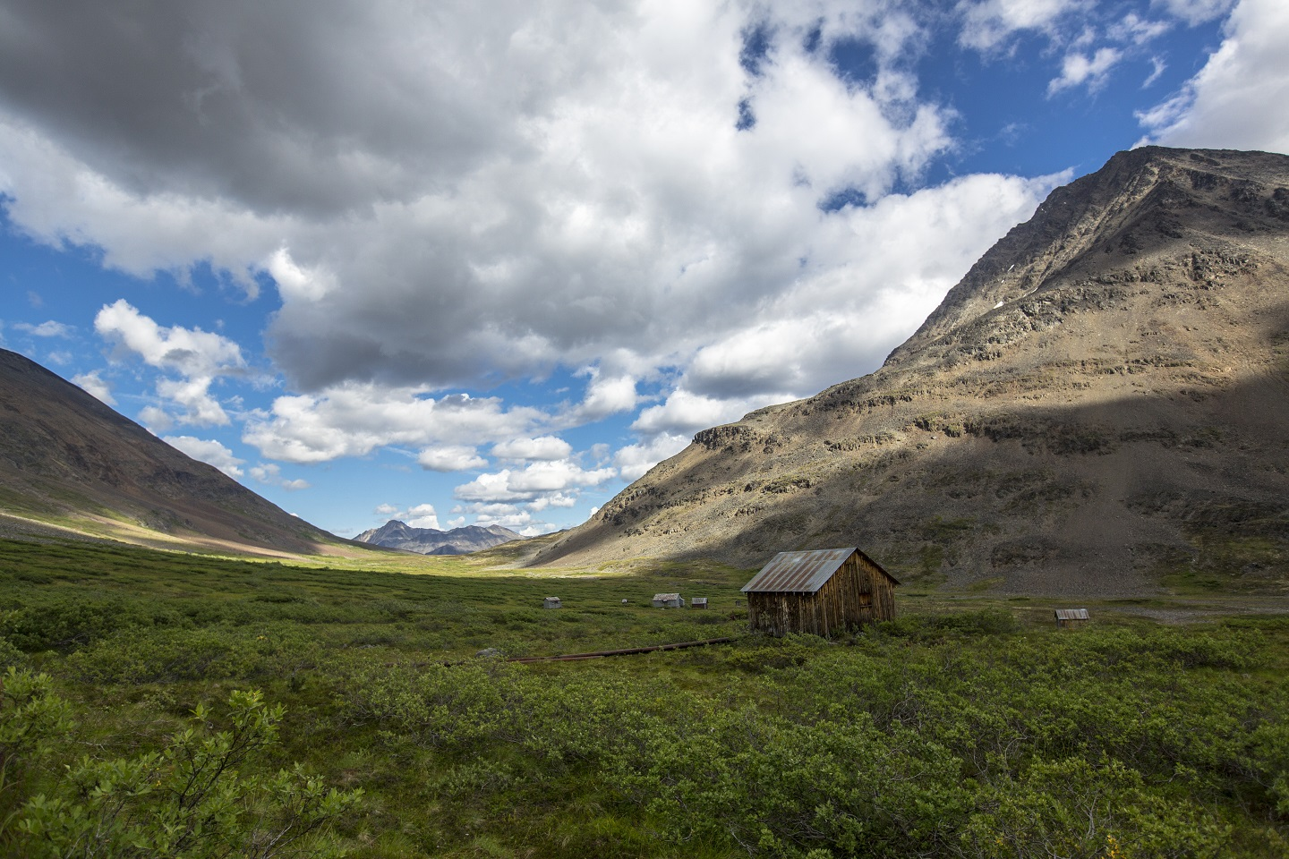
The selected artist will spend 3-6 weeks at the Bremner Historic District. The artist will help protect cultural and natural resources in the area, contact park visitors who are passing through, and record visitor use information. The artist is encouraged take day patrols in the area, which provides excellent opportunities to explore. Artists will have plenty of time to take in the sights and sounds of the scenic landscape. The selected artist will have outdoor experience and be physically and mentally prepared for living in a primitive cabin for multiple weeks. The cabin does not have running water or electricity; however, the park provides a small solar panel which can be used to charge small devices. The site is lightly furnished (cots, propane stove, park provided propane, cooking utensils, etc.), and has an outhouse. Artists must be able to travel comfortably in the wilderness and off-trail and be comfortable working in bear country. Artists are encouraged to bring a friend or a partner (two people total is optimum and both must have the requisite outdoor experience). Artists will depart for the wilderness from McCarthy, Alaska.
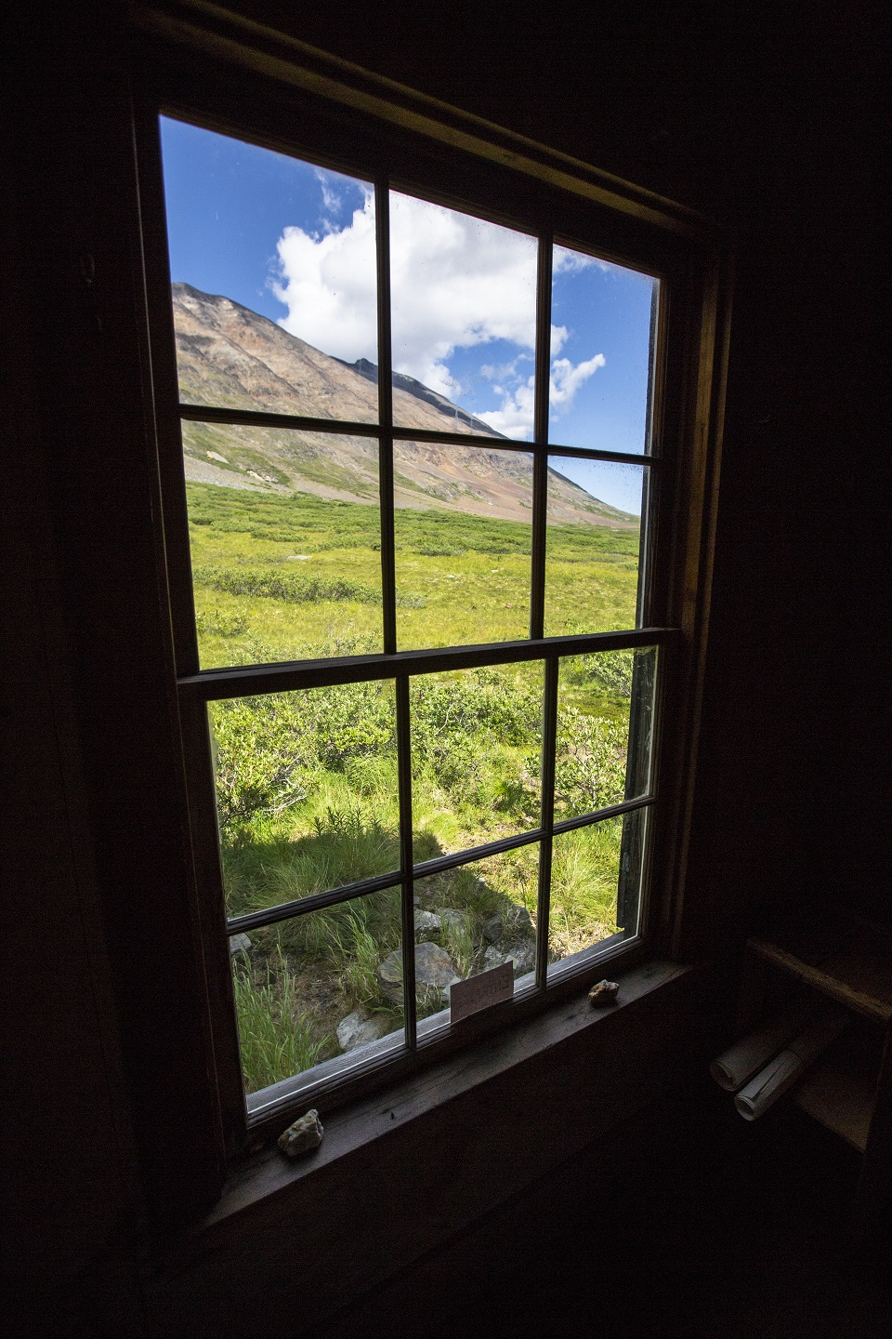
Contact Wilderness Coordinator Nyssa Landres at nyssa_landres@nps.gov or
(907) 822-7240

APPLICATION PROCESS FOR OUR 2020 RESIDENCIES:

How to Apply:

To submit: Applications must be emailed to blydon@fs.fed.us; no paper applications will be accepted.

* Include three attachments:

• 2020 application filled out, unlocked PDF format or Word formatted document. All text must be typed.

• A resume no more than 2 pages, in either PDF or Word formatted document

• Six Artistic samples composed in single PDF or Word formatted document, 5 MB max., six pages maximum (one artistic sample per page).

-For each sample, include descriptions of artwork with title, materials and dimensions of work:

-Visual Artists (i.e. Photographers, Sculptors, Painters, etc.): Six color photos.

-Writers: Six pages of written examples (prose, short stories, plays or poetry).

-Musicians/Composers: Musicians and composers should submit lyrics and recordings of their work (links to recordings is fine to include)-six recordings total.

-Multidiscipline Artists: Send appropriate sample combinations, six color photos.

* In the ‘subject’ of the email, include your last name & your artistic medium, for example, “Lydon-Ceramics”.

• Submit only one application, even if applying to multiple residencies.

• Insufficient materials or incomplete application are causes for rejection, as are an artist’s proposed use of a work already in progress as a residency project. Zip files, Google Documents, Dropbox, etc. will not be considered.

• Finished artwork and community extensions must be completed and donated within six months of completing your residency.

• This original artwork resulting from the residency will be donated to the United States Government, which means that the artist relinquishes publishing and reproduction rights to that work.

• Selected artists agree to provide a high resolution, professional quality digital image of their completed artwork to use for publicity and educational purposes.

• Selected artists agree to submit a summary of their community extension and projects/outreach associated as a result of their residency.

• Emailed applications are due by 11:59 PM AK time March 1, 2020. Artists will be chosen by mid-April by a panel of professional artists and federal employees. Selections will be based on artistic merit, proposed donations/community extensions, and appropriateness to a stewardship-based wilderness residency. All applicants will be notified of decisions via email. Unfortunately, we are unable to provide feedback on applications, either before or after being submitted.

• Please note that due to unforeseen budget constraints in the spring, some residencies may not be offered.

• Your application is very important to us. If you do not receive a confirmation email stating we’ve received your submission, it may not have gone through. Please contact program coordinator Barbara Lydon at barbara.lydon@usda.gov if you don’t receive a confirmation email within a week of submitting your application and supporting documents.

For more photos and information from our past residencies, visit http://www.fs.usda.gov/goto/votw

Checklist for 2020 VOTW submission:

Label subject of email: “Your Last Name - Your Medium”

There should be 3 attachments included in your email to blydon@fs.fed.us:

- The filled out 2020 application
-Save as “Application_Your Last Name”
-Save as “.pdf or .docx” formatting

- Six artistic samples in a single document, 5 MB maximum
-One sample per page, not to exceed 6 pages
-Save as “Samples_Your Last Name”
-Save as “.pdf or .docx” formatting

- Resume of no more than two pages, in a single document
-Save as “Resume_Your Last Name”
-Save as “.pdf or .docx” formatting

Qualification

Residencies are open to artists of all mediums. Selection will be based on:
• Appropriateness to a stewardship-based wilderness residency
• Proposal for donated artwork and community extension, and willingness to work with the federal agencies to make this program a success
• Artistic merit
• Ability to camp in a remote location and travel by skiff, airplane and sea kayak, and willingness to assist with light ranger duties. (Extensive backcountry/kayaking experience is not necessary for all residencies, just capability.)

Artwork Donations

The goal of the Voices of the Wilderness program is to share the scenic beauty and inspirational values of Alaska’s wilderness areas, through the talents and reflections of professional artists. Each participant is expected to donate one piece of artwork to the hosting federal agency for use in highlighting the values of our public lands. Donated artwork should be representative of the area and communicate its inspirational or other values.

• Artwork should be delivered to the appropriate agency office within six months of the residency.
• Artwork from visual artists should be framed with glass or otherwise prepared for hanging before donation.
• An electronic, high resolution digital image of the completed artwork must be provided by the artist prior to receiving the donation.

The artwork will be shared with the public through exhibition, publication, websites, or other means. The original work resulting from the residency will be donated to the United States Government, which means that the artist signs over publishing and reproduction rights to that work.

Community Extension
.
Artists are expected to provide one public presentation within six months of completing their residency, such as a slideshow lecture, demonstration, or workshop that publicizes the program and connects the community to their public lands. Other examples include a performance, explorative hike, or participation in a public lecture. The presentation can be tailored to an individual’s medium, interest and experience, but each artist must provide supplies, equipment and logistics for the presentation. Community extensions do not have to take place in the community of the residency.

Collaborative Applications

Two artists are invited to submit an application together only if both are needed to successfully accomplish the proposed project and community extension, though many hosting wilderness areas may not be able to accommodate a pair of artists.

Please note--If artists would like to be considered individually as well for a collaboration, they must submit a separate application geared towards a project and extension conducted by a single artist.

Details on how to submit a collaborative application:
-Label subject of email should read: “Both Last Names – Your Mediums”

-Submit three attachments in your email:
1. The filled out 2020 application
-List contact information for both artists
-Save as “Application_Last Name and Last Name”
-Save as “.pdf or .docx” formatting

2. Six artistic samples total (three from each artist) in a single document, 5 MB maximum
-One sample per page, not to exceed 6 pages
-Save as “Samples_Last Name and Last Name”
-Submit only six artistic samples total (three from one artist, three from another—or six total if you have collaborative pieces)
-Save as “.pdf, .docx, or .jpeg” formatting

3. Resume of no more than two pages, in a single document
-Save as “Resume_Last Name and Last Name”
-Save as “.pdf or .docx” formatting
-Submit a single two page resume for both artists showing collaborations, or submit a single page resume for each individual artist

…………………………………………………………………………………………………………………………………

All emailed applications are due to barbara.lydon@usda.gov by 11:59 PM AK time March 1, 2020

Good luck, and thank you for applying!

